Changes for mfnir_jeff

1. Must have dark current reading (all LEDs are off) for every phase
   1. Kept the i = 0…4. Format for phase (24 ms each). Where
      1. i = 0. LED1 730 nm on
      2. i = 1. LED1 850 nm on
      3. i = 2. LED2 730 nm on
      4. i = 3. LED2 850 nm on
      5. i = 4. Everything off (maybe we don’t need this anymore since we are reading dark current at every phase.

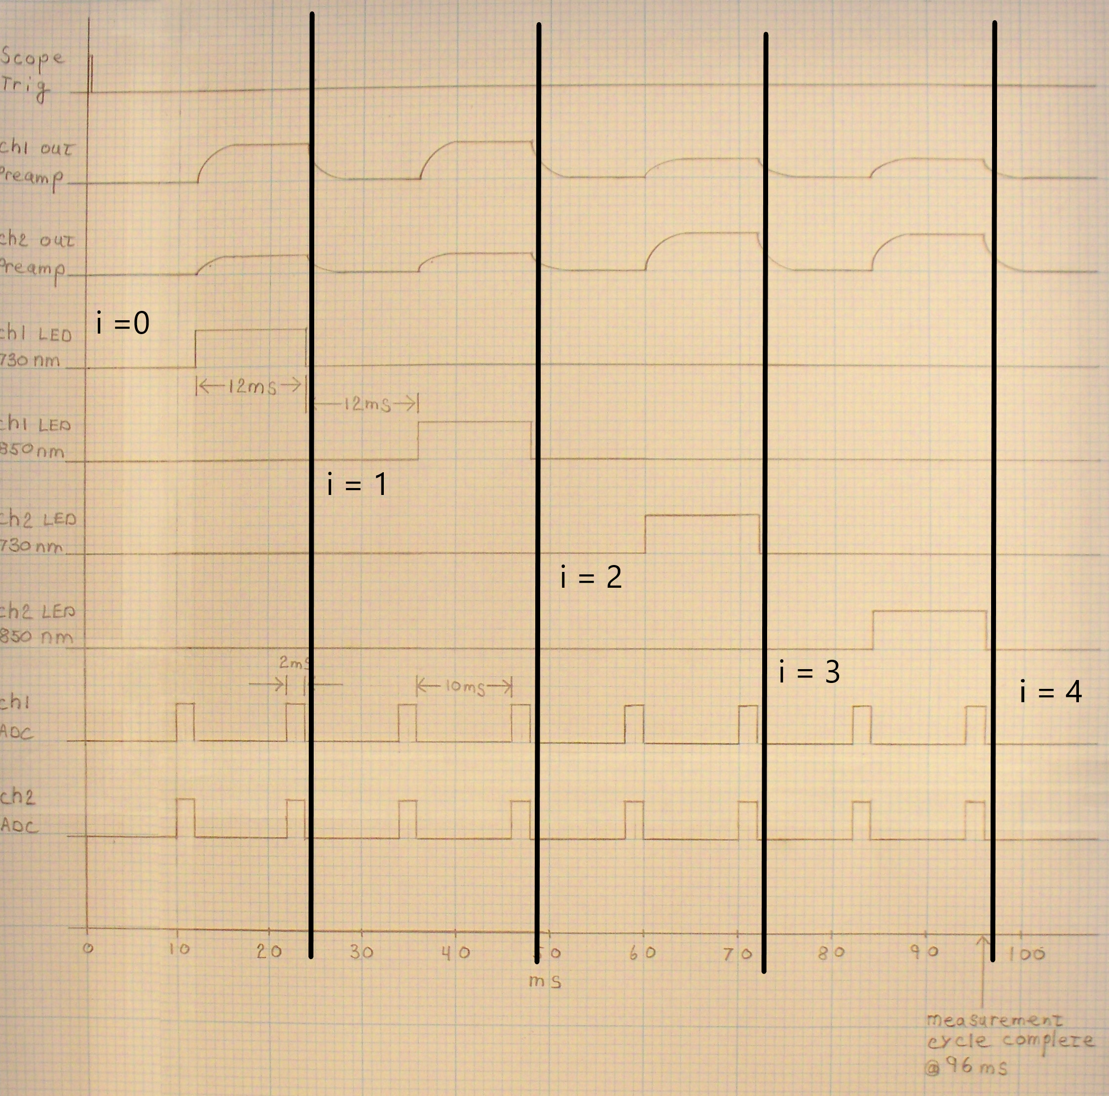

1. Changed values on existing variables (in constants.h)
   1. onDelay = 10
      1. Since we are reading from ADC at the end of the 12 ms cycles
   2. Freq = 150000
      1. For 150kHz
2. Probe only has 2 channels.
   1. Ch3 and ch4 were assigned dummy values to keep size of data the same for the MATLAB codes
3. New function: analogReadFunction(const int dly_avg, const int n_reads, const int sensorPin)
   1. Line 160-176 in main.cpp.
      1. Do I have to make a .h file and put it in the include folder?
      2. Placing it at the end of the main.cpp doesn’t work
   2. Inputs:
      1. dly_avg (in us) = Duration of the delay per detector read.
      2. n_reads = number of times detectors are being read. e.g. n_reads = 50 --> the detetctors is averaging between 50 values
      3. sensorPin = Which pin are you reading. As each time this function is called, different pin inputs are inserted (in the main loop)
   3. New variables (in constant.h)
      1. dly_avg = 2 //in us
      2. N_reads = 50 //50 readings at 2us in between, thus 1 ms per channel.